Comparative Analyses in Ecology and Evolution
project:

Investigating brain size and body mass evolution in mammals in relation to home range area

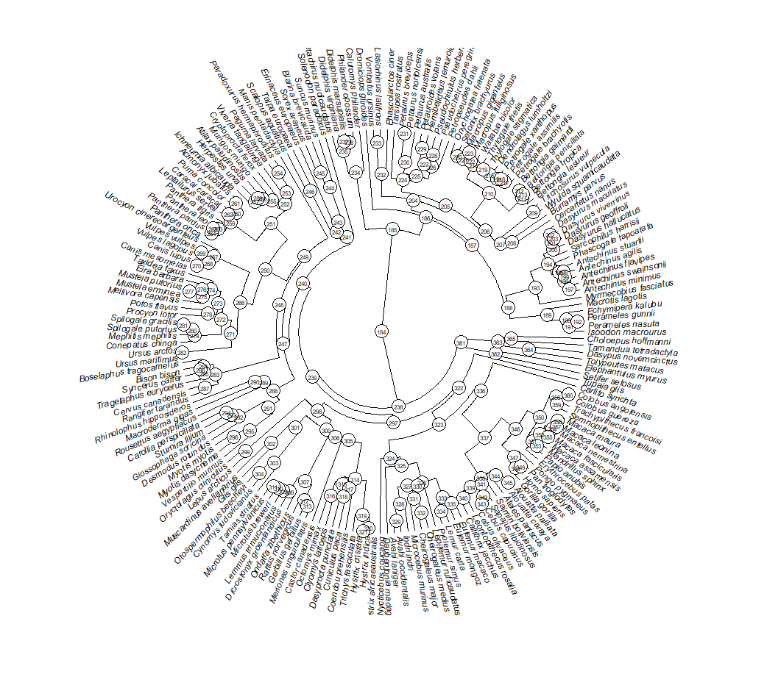

Yarmak Mariia, Biology BSc

- Linear regression

p-value: 0.998
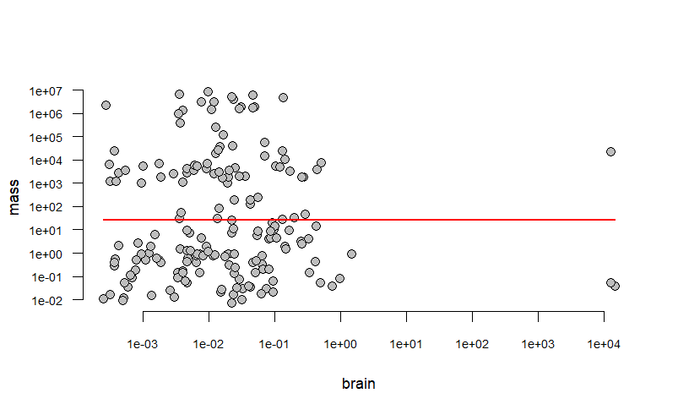
The relationship between brain (kg) and body (kg) mass does not appear significant, with relatively conservative brain mass distributed between widely varying body masses.

- Having accounted for phylogenetic relationships using phylogenetically independent contrasts we can observe a rearrangement in clustering of the species, with more closely related ones sharing a more similar body mass-to-brain mass ratio. Despite this, the relationship between the parameters is still insignificant.

p-value: 0.6943

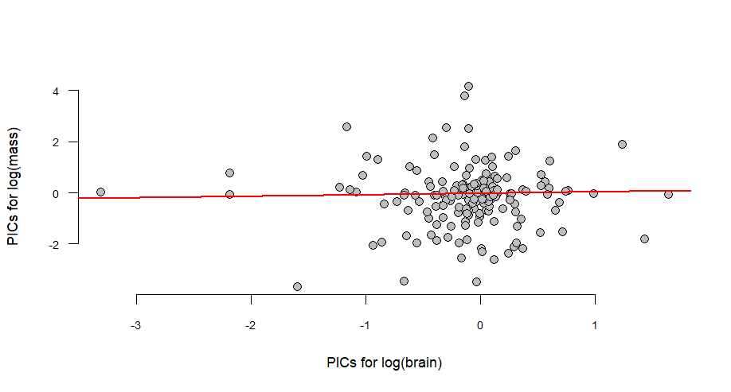
3. In contrast, home range (km²) seems to have a heavy correlation with body mass when phylogeny is unaccounted for. The relationship disappears with application of PICS (p-value: 0.2347). 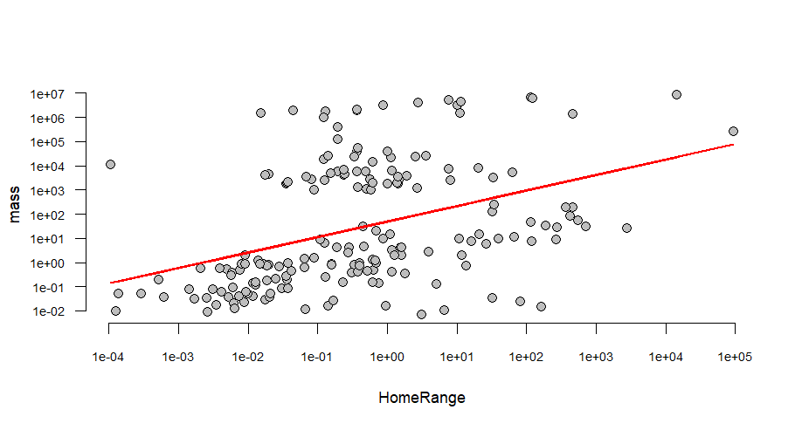
4. Phylogenetic signal K for all 3 traits is below 1, and less than expected for this tree, which means that relatives resemble each other less than expected under Brownian motion.
5. Although Pagel's Lambda for both brain-mass and brain-home range interactions is close enough to 1 to suggest Brownian motion evolution, Ornstein–Uhlenbeck model is the most fitting for each trait separately.

Conclusions
I was unable to determine a clear relationship between the parameters, however, three observations point to the presence of such a relationship:
- dramatic outliers in brain-mass ratios even when corrected for phylogeny;
- phylogenetic signal K values, and a suggestion that all three traits might have developed towards a certain optimum;
- Principal component 1 which establishes a negative relationship between larger body mass and larger home range area and brain mass.

Resources:
https://animaltraits.org/
https://knb.ecoinformatics.org/view/doi%3A10.5063%2FAA%2Fnceas.196.3
https://timetree.org/

